Suggested Legislative Recommendation:
The Texas Legislature should provide resources for the TWDB to annually review and publish water conservation and reuse best management practices (BMP) for water volumes saved and reused as part of the mandatory municipal Water Conservation Plan Annual Report.

Background
Texas is the nation’s leader in water supply planning through both the regional water planning process and the significant amount of data that supports the planning process, including groundwater models, surface water models, and annual detailed water use of public water systems. With each iteration of the regional and state water planning process, the Texas Water Development Board (TWDB) provides additional valuable data which improves the planning process.
All water utilities that are required to submit a Water Conservation Plan must submit an Annual Report of conservation and reuse activities.
The next opportunity for improving water use management is to better understand the amount of water actually saved and reused by water conservation and reuse activities (or BMPs).

Why is it important to review and post the Annual Report volumes of water saved and reused?
Successful planning efforts include cycles of improvement: quantify needs, find solutions, implement, evaluate and adjust the solutions to continuously improve.
Regional water plans and individual utility conservation and supply plans are generally based on projected volumetric savings from water conservation and reuse programs. Very rarely are the estimated volumetric results of the conservation and reuse efforts available.

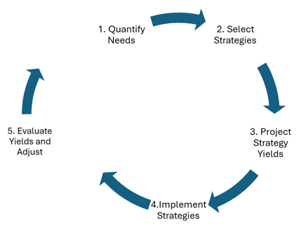
The regional water planning process is also missing the final piece (#5) for municipal water conservation.
The 2015 Goldwater Project found that there can be a significant difference between water conservation planned for and conservation implemented and executed.

Water Conservation Plan Annual Report
For over a decade, Water Conservation Plan Annual Reports have been required by the TWDB for all Texas water utilities that have to submit a 5-year Water Conservation Plan. These reports contain information regarding customer connections, utility water use accounting, per capita water use (gallons per capita per day orGPCD), and conservation program activities (BMPs) and volumetric yields. See an excerpt on the next page and the attached 2024 Report submitted by City of Austin Water Department.

BMP implementation and estimated gallons saved or reused (except from the City of Austin Annual Report)
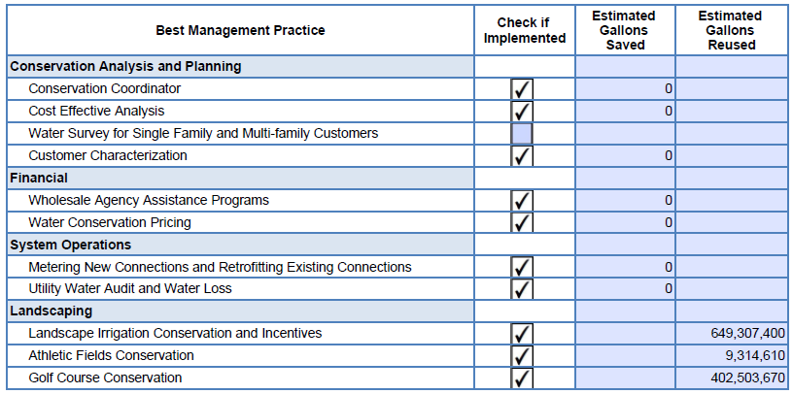
Some of the important data – customer connections, water use accounting, and GPCD – is currently posted on the TWDB’s Annual Conservation Report Historical Data website. BMPs being implemented are also posted for utilities on TWDB’s Conservation Information Dashboard for Water Supply Planning, however, the current information posted contains no volumes of water saved or reused
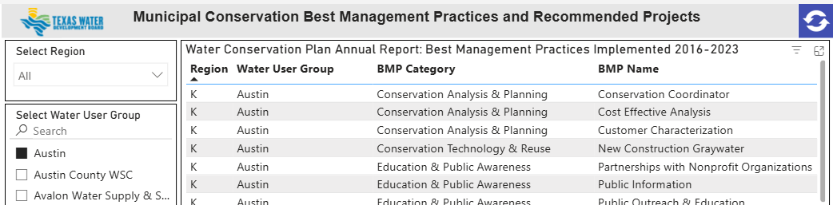

FAQs

Does the TWDB already post the data from the Water Conservation Plan Annual Report?
Some of the data from the Annual report is posted on the TWDB website
- Customer connections, water use accounting, and GPCD - Annual Conservation Report Historical Data
- Reported conservation/reuse BMPs - Conservation Information Dashboard for Water Supply Planning
The reported volumes saved or reused from the BMPs are not posted.

Doesn’t the reported and posted GPCD values indicate the effectiveness of municipal water conservation?
No, not in the 5-year timeframes utilized in the Water Conservation Plans and the Regional Water Planning Process. The greatest determinants of Total and Residential GPCDs in that timeframe are weather (temperature and precipitation), water loss events (such as systemwide leakage, significant line breaks or meter malfunctions), and the addition or deletion of large commercial/industrial customers.
The effectiveness of conservation efforts should be based on the estimated volumetric results of the implementation and execution of programs (BMPs)

Will this cost water utilities more?
No. The Annual Report has been required from water utilities for over a decade. The TWDB has created a Municipal Water Conservation Planning Tool that can be downloaded which provides an estimated water savings from BMPs. In addition, the Alliance for Water Efficiency also offers a Water Conservation Tracking Tool for its member utilities.

Is there a gap between conservation planned volumes and conservation implemented volumes?
Yes, there may be significant gaps.
The 2015 Goldwater Project, by Kip Averitt & Associates, working with the Region H Water Planning Group, quantified ongoing water conservation programs in Region H and found a significant variation in the current water savings compared to projected savings. Averitt describes the project as “… helping the TWDB by being the “last mile” between the self-reported water conservation plans it requires from utilities and the actual implementation and tracking of conservation in real time.”
A 2017 Statewide Water Conservation Quantification Project, prepared by Averitt & Associates, Inc. for the TWDB observes that “…the way water management strategy (WMS) supply volumes for municipal conservation are developed do not facilitate an easy assessment by the utilities expected to meet these future supply volumes.” (p. 3) The project report recommends:
- “The state should potentially develop a process to standardize and improve bottom-up (as described in Section 5) conservation savings estimates.”
- “By establishing such a system to annually estimate bottom-up savings to compare with savings results from the topdown approach currently being employed by the state, an understanding of true conservation savings would emerge and should help water planners to gauge conservation on a yearly basis, rather than every five years with much greater uncertainty.” (p. 4)

The 2015 Goldwater Project with Region H cannot be found online, but is described in a 2016 Analysis of implementation of water conservation strategies by regional water planning groups by Ken Kramer. Kramer_rwpg_implementation_2016.pdf
Confidence in Conservation: The Way Forward for Texas

